Data analysis and results

In order to answer the research questions, both quantitative and qualitative methods of data synthesis and analysis were used, as both types of data were involved in this study. These methods include descriptive statistics for synthesising and analysing the quantitative data involved in the questionnaire; thematic analysis for identifying developers' perceptions of project success factors and organisational structures; and narrative analysis to understand how respondents expressed their experiences of project practice and their perceptions of project success factors.

***RQ1:How do Internet practitioners perceive the importance of project impact factors?***

We first obtained Internet practitioners' overall perceptions of the project's impact factors by placing questions related to the six impact factors of the project in the questionnaire, and then analysed how they made judgements about the project's impact factors.

***RQ1.1: To what extent do different factors influence the project?***

According to the results of the questionnaire survey shown in the figure below, almost all Internet practitioners who scored the importance of the factors that contributed to the progress of the project endorsed communication coordination (97.62%) and quality of decision-making (95.24%) as important influences, followed by technical realisation (85.71%), process management (78.57%), performance incentives (69.05%), and organisational structure ( 64.29 per cent).

The figure below shows how the surveyors scored the six influencing factors of the project, communication coordination (98.7%) and quality of decision making (95.24%) as the only project influencing factors with more than 90% approval rate, its undoubtedly considered as the most important factor, and compared with other project influencing factors (technical realisation), communication coordination is usually the one that has the most intuitive connection with each employee in the project. As a result, Internet staff are paying more attention to communication coordination as an important impact factor.

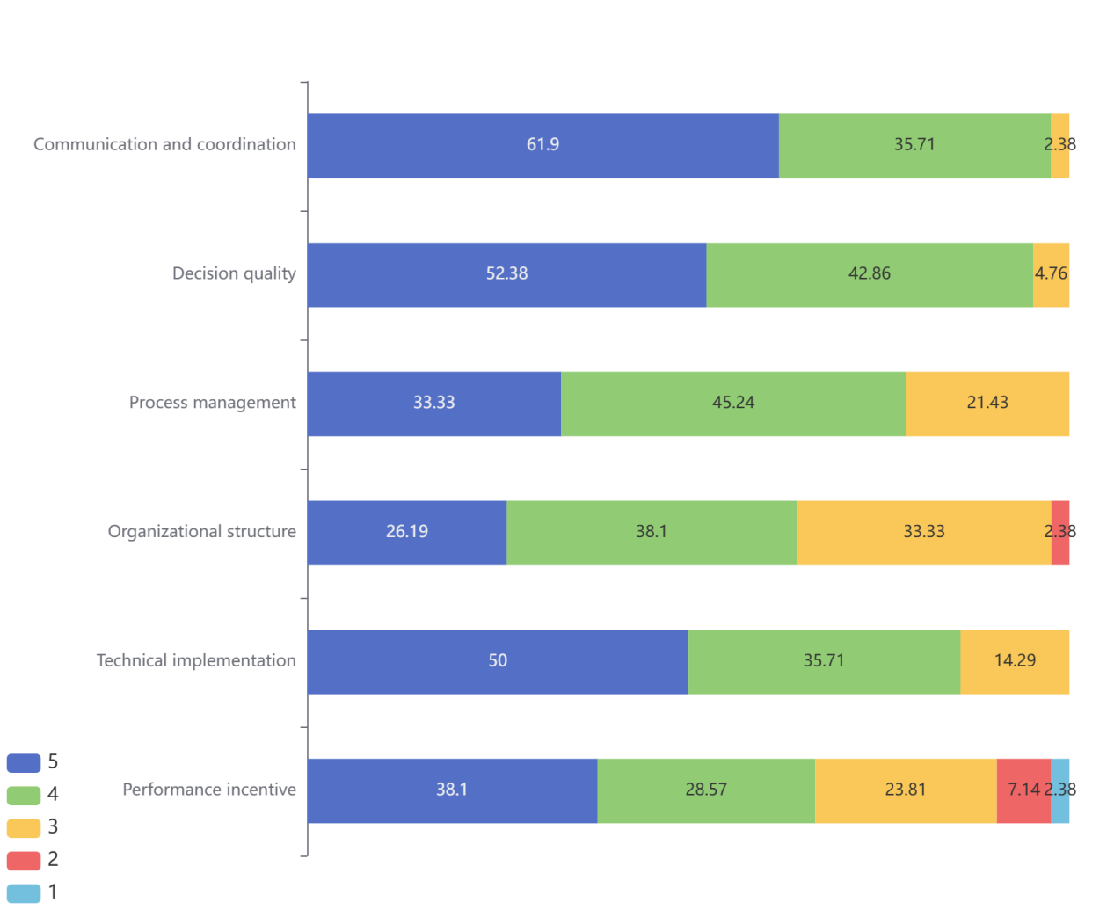

Figure: Importance of different project impact factors

1)We next cross-analysed more relevant responses on project impact factors and also made the following observations based on their roles and years of experience, mainly related to examples of the application of project impact factors.

2)The importance of communication coordination and quality of decision making is recognised by almost all practitioners, regardless of their role and years of experience.

3)Regarding the project communication channels, regardless of the background of the survey respondents, the survey respondents more face-to-face communication, while its effectiveness has been recognised by more than ninety percent (95.24%); network communication, telephone communication and email communication is also commonly mentioned communication channels, but the effectiveness of email communication recognition is only 35.71%, and regardless of the role of the survey respondents and work for several years. At the same time the project's promotion scheduling meeting managers and development team are more than half of the people support once a week, while the product leader to pursue a higher frequency of communication.

4)At the start of the project, all project roles agreed that the clarity of the project requirements should be taken seriously, while almost everyone (except one) recognised the importance of the impact of changes to the project requirements.

5)Managers and product owners in the project are more critical of the internal processes involved in the project, which are not seen as supporting the project functioning well.

6)Regarding the problem of overlapping and misalignment of authority of certain departments in the project, more than half of the survey respondents in all project roles indicated that there are corresponding problems.

Finding：

(1) Communication coordination and decision-making quality are the most important influences on projects, a finding confirmed by this mixed-methods study.

(2) There is no clear relationship between practitioners' profiles and the extent to which they recognise the influencing factors of individual projects, however, the focus of each role is inconsistent.

Interview Sentence: "In development I think communication and decision making affects how efficiently people can do their work, and also an important thing is whether the technology can be realised? And also performance incentives after working for a long time can improve people's efficiency." --Lee

"Firstly I think there are three most important factors for the success of project development, the first one is the communication problem, people may be biased in relaying requirements. The second one is the key decisions in the project, which also determines the success or failure of the project. The third is the organisational structure, which relates to internal organisational interfacing, etc." --Feng

***RQ1.2: How does the organisational structure impact on the overall project process?***

In further interviews, organisational structure (broadly defined as organisational issues that encompass communication channels within the organisation, job changes, reporting management, etc.) was identified as an integral factor in the project, and there were some influencing relationships between it and the other project influencing factors, and in order to understand how organisational structure impacted on the process of the project, we carried out a cross-tabulation analysis, based on their responses to the extent to which they recognise the organisational structure and the specific application of the project influencing factors, respectively.

The chart below shows that most Internet practitioners recognise the existence of an impact of organisational structure on communication coordination and decision-making quality. Respectively, 90.48% and 83.95% of the survey respondents believe that organisational structure has a large impact on communication coordination and decision-making quality, and well over half of the respondents recognise the importance of organisational structure, a fact that highlights the fact that respondents are also more aware of organisational structure amongst the influencing factors of the project.

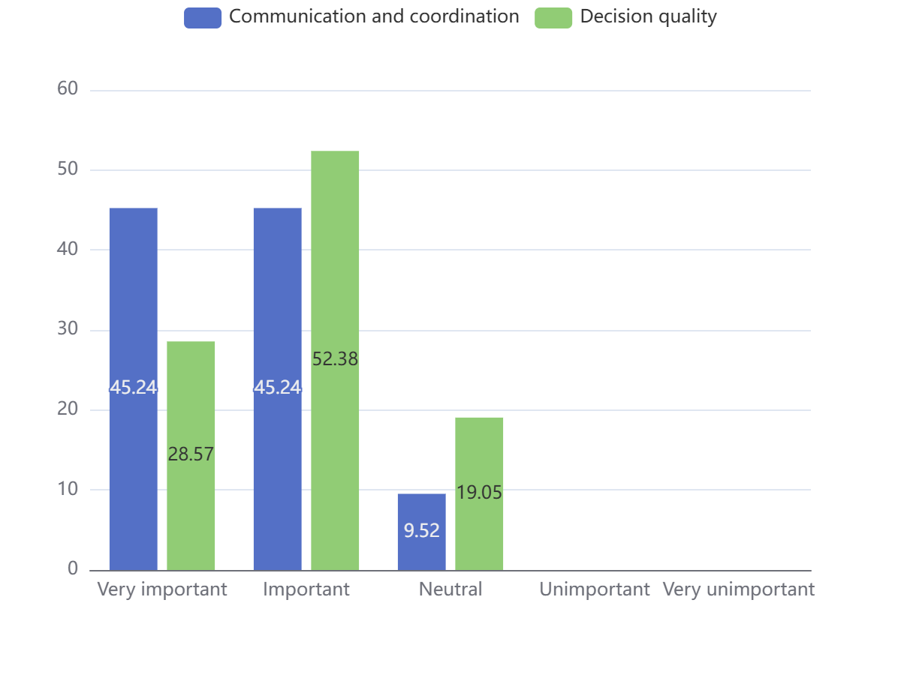

Figure : Impact of organisational structure on the existence of communication coordination and quality of decision-making

Finding: communication coordination and quality of decision making are the most important project influences, and more importantly another important project influence, organisational structure, was identified.

The specific impact of the organisational structure on the project is also reflected in the vertical and horizontal communication during project facilitation. As for the question on the effectiveness of horizontal communication across project departments and vertical cascading within departments, 11.9 per cent of the respondents felt that the work to be coordinated could not be carried out well.

When asked about the importance of reporting and feedback in the process of project promotion, only 2.38 per cent of the respondents considered it unimportant. However, when asked whether they were satisfied with the implementation of reporting and feedback in the process of project promotion, only 54.76 per cent of the respondents said that the implementation was high.

As shown in the figure below, which illustrates the recognition of the importance of reporting and feedback at all levels of the project facilitation process and its execution by people with and without experience of failed projects, only 45 per cent of respondents with experience of failed projects were satisfied with the degree of execution, compared to 63.64 per cent of respondents without experience of failed projects, so that there are even more problems with vertical communication in the case of failed projects.

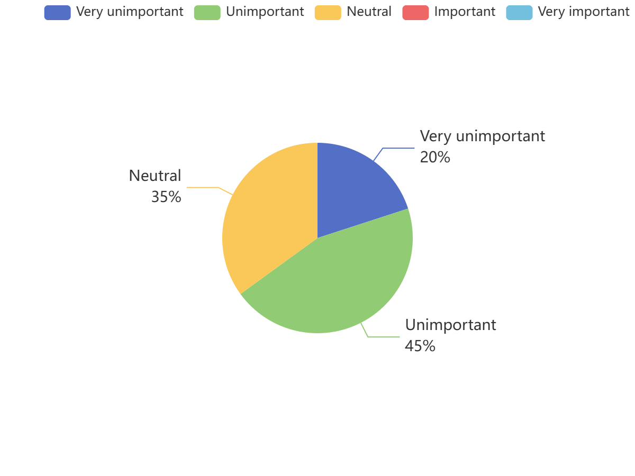

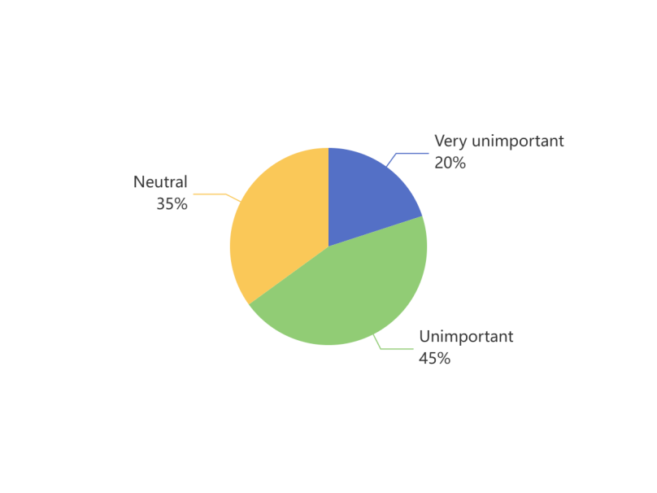

Figure : Recognition of the importance of vertical transmission of project information by those with experience of failed projects

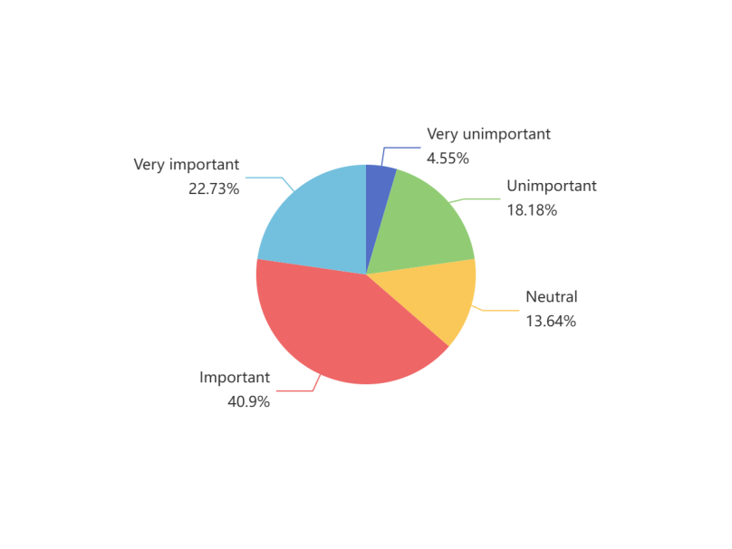

Figure : Recognition of the importance of vertical transmission of project information by those with no experience of failed projects

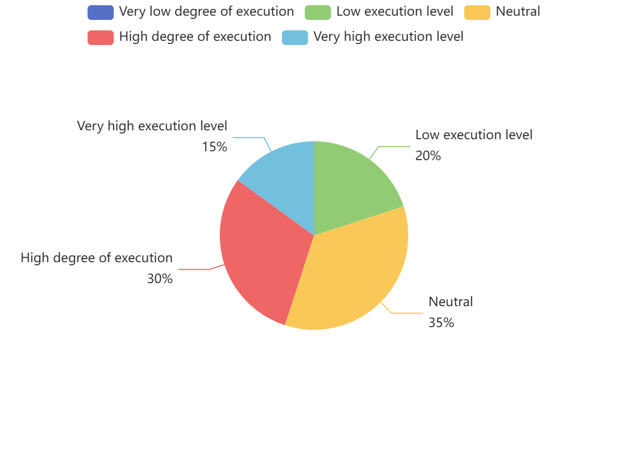

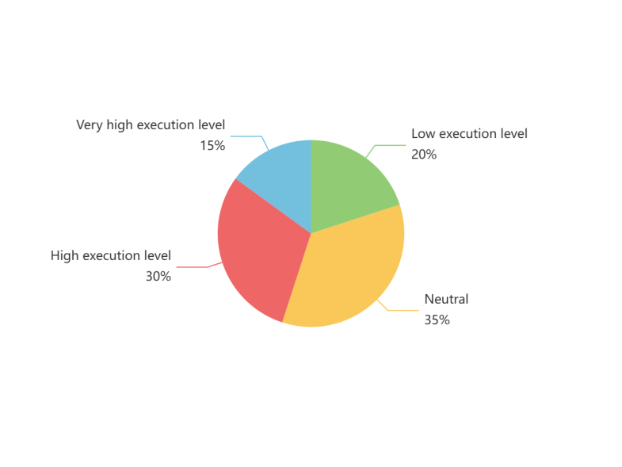

Figure: implementation of vertical transmission of project information as perceived by those with experience of failed projects

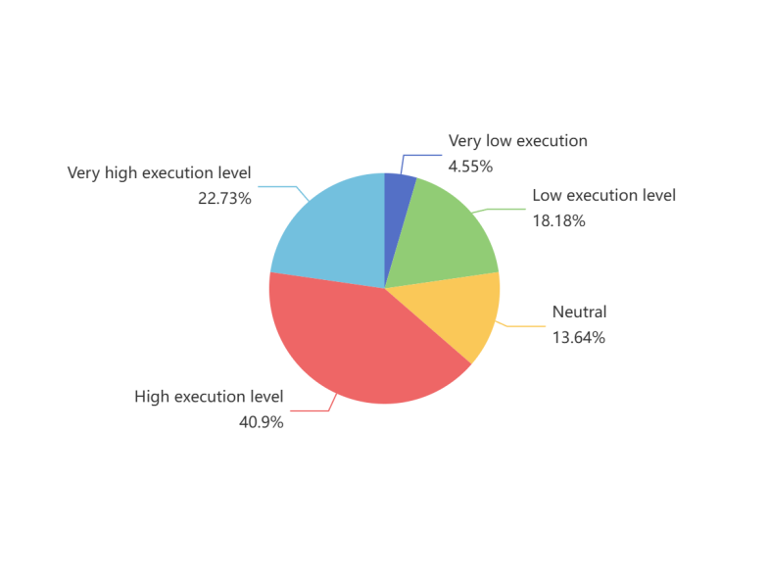

Figure: implementation of vertical transmission of project information as perceived by those with no experience of failed projects

Finding: organisational structures are established, while communication and decision-making mechanisms are defined, and there are some relationships between horizontal and vertical feedback on projects and organisational structures. Internet practitioners perceive failed projects as having more problems with vertical management reporting processes.

Interview Sentence: "After understanding the meaning of organisational structure I think it is very important, organisational structure, quality of communication, quality of decision making and process management are more important because the important thing about software is that the requirements can serve this business, for the department the technology doesn't need to be very advanced but it needs to be a facilitator for the whole business. The organisational structure is established and also the communication and decision-making mechanisms. For example, three parties of project managers work together to confirm the final requirements. If one party lacks a project manager, it will result in that party not being able to confirm the requirements because of the lack of leadership." --Chapter

"A failed project I was involved in had no good organisational structure to drive it from the start, the leadership did not take it seriously during the reporting process from level to level, and there was not a quality drive. We as party B had problems with miscommunication and lack of attention when reporting at the middle level." --Feng

***RQ2:How do Internet practitioners' project experiences influence their choice of organisational structure?***

We provided the interviewees with four choices of organisational structure, namely tree structure (highly centralised decision-making, problems are reflected from the top down and cascaded to the top level, solutions are decided at the top level, and implemented from the top down and cascaded to the bottom level), ring structure (flat management, which reduces intermediate management levels, and encourages direct communication and collaboration between employees and management), forest structure (problems are reflected from the bottom up in the department, and decisions are made in consultation with the top level of the departments), and graph structure (open management, where problems are freely reflected, and decisions are made in consultation with the top level of each department). ) and graphical structure (open management, where issues are freely reflected and decisions are negotiated across departments).

After analysing the figure below, we find that 45.24% of the interviewees consider ring structure as their ideal organisational structure, 38.1% are more in favour of the use of tree structure, 14.29% prefer the forest structure, and a very small percentage of people are willing to use the graphical structure. It can be concluded that majority of the people preferred ring and tree structure.

Next, we will cross-analyse the choice of organisational structure in terms of the number of years worked, the position held and the type of firm, respectively.

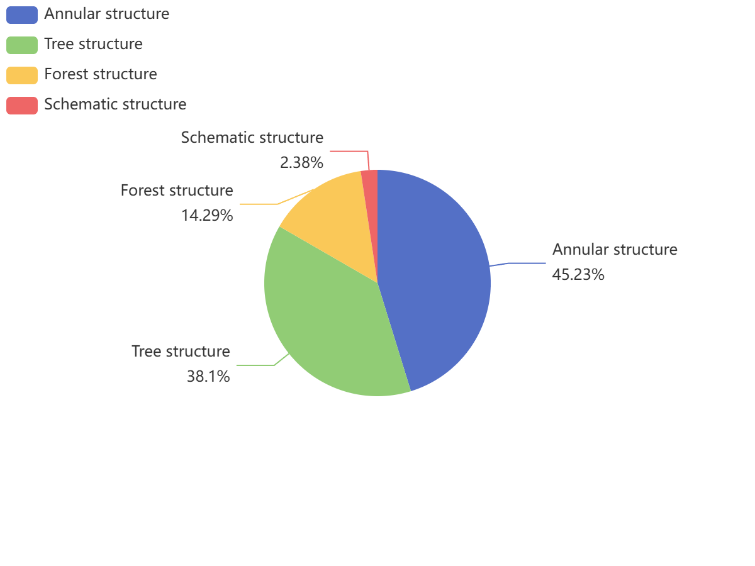

Figure : Which of the following organisational structures do you think makes more sense during the project?

1)According to the survey responses, the choice of organisational structure varies greatly by years of experience. See the chart below, half of the interviewees with less than one year of work experience chose a forest structure, and the rest chose a tree structure and a ring structure respectively; more than half of the interviewees with one to five years of work experience supported a tree structure, followed by a ring structure, and the forest structure accounted for the smallest share; among the interviewees with six to ten years of work experience, those who supported a ring structure accounted for most of the interviewees, with part of the supported the tree structure, and only a small percentage chose the graphical structure; nearly half of the interviewees with more than eleven years of experience were more accepting of the ring structure, followed by the tree structure.

A cross-tabulation analysis between the choice of organisational structure and the interviewee's years of experience yielded that those with less than five years of experience favoured the choice of a tree structure and those with more than six years of experience favoured a ring structure, as shown in the figure below. It was further found that those with more experience tended to encourage direct communication and collaboration between employees and management, thus improving communication efficiency.

Interview: "An older leader will be more knowledgeable than me, and he knows more about this project than the employees, so it may be preferable to report layer by layer. The ring structure may be more convenient for communication, and direct communication will be more efficient." --Lee

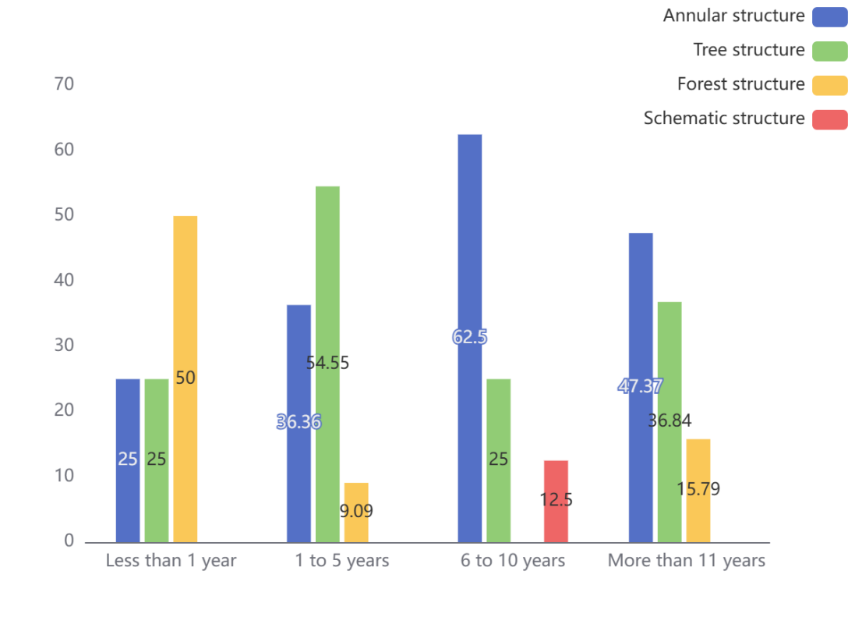

Figure: Distribution of organisational structure choices by years of service

2) In addition, the choice of organisational structure varied considerably between the different roles in the project. The results of the analysis are shown in the figure below, the majority of the managers in the project chose the ring structure (66.67%), the rest chose the tree structure, and no one chose the forest structure and the graphical structure; the majority of the development team in the project likewise chose the ring structure (52.94%), and a small number chose the tree structure and the forest structure; while the product owners were more inclined to the tree structure ( 62.5 per cent), a small proportion chose ring and forest structures because they felt that it was easier for the leadership to make quality decisions, as illustrated by interviews with several employees.

Interview : "As an employee I chose the tree structure, when I encounter problems I can report them to my leader, my leader and the other's leader communicate directly, it doesn't require everyone to be directly involved in the communication." --Lee

A cross-tabulation analysis between the choice of organisational structure and the roles of the interviewees led to the conclusion that managers and the development team favoured the choice of a ring structure, and employees such as product owners favoured a tree structure.

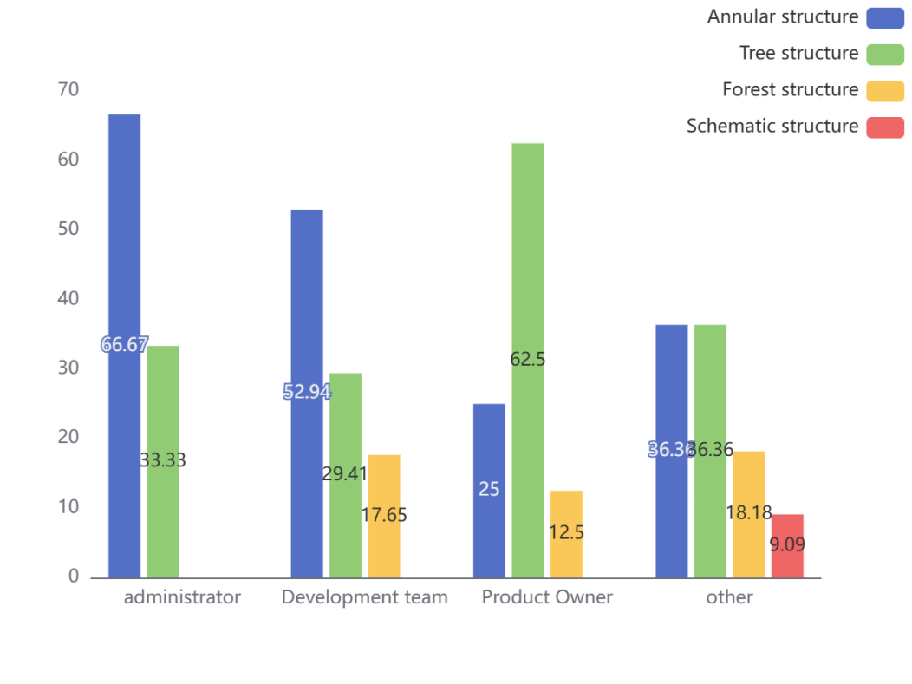

Figure : Distribution of choices of organisational structure by different roles in the business

3)The choice of organisational structure varies greatly from one enterprise to another. According to the questionnaire feedback analysis of the results shown in the figure below, the type of enterprise is a private enterprise, 41.67% of the respondents chose the tree structure, and furthermore, it is concluded that most of the private enterprises in the decision-making is more centralised, more inclined to the problem from the bottom up to the level of the reflection of the senior management to decide on the programme, and from the top down to the implementation of the level by level.

Interview: "For large private companies, one leader can't manage so much, so I think the tree structure will be a bit more scientific, because I understand down, Huawei is actually also a tree structure" - Feng

Of the survey respondents whose type of enterprise is state-owned and state-controlled, 57.89% chose a ring structure, so state-owned and state-controlled enterprises are mostly seen to have flat management, which encourages direct communication and collaboration between employees and management.

Interview : "Because I'm talking about the government sector, the tree structure is all about more highly centralised decision making, so this is also in line with our actual situation, and in our practice we found that the efficiency of decision making in the tree structure is more conducive to the advancement of this project." --Chapter

A cross-tabulation analysis between the choice of organisational structure and the type of business yielded that people in private companies preferred a tree structure and people in state-owned and state-controlled companies preferred a ring structure. 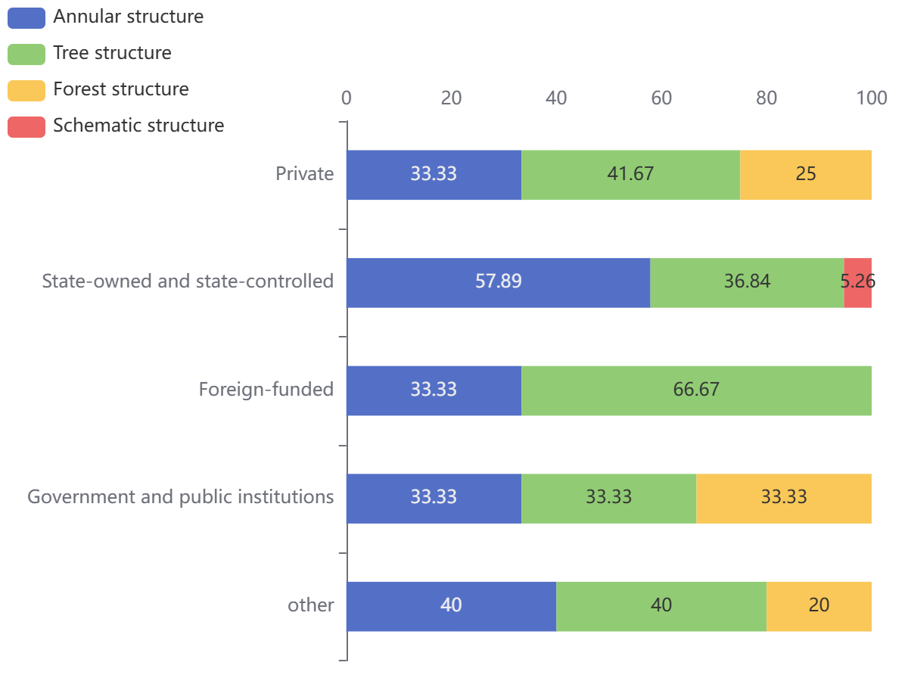

Figure : Percentage of people in different businesses choosing different organisational structures

Finding:Information technology practitioners have a greater preference for ring and tree structure organisational structures. However, project experience affects their choice of organisational structure: (1) Internet practitioners with more work experience prefer ring structure, which leads to more efficient communication. (2) Managers in the project favoured a ring structure and preferred a direct communication approach across departments. (3) People in private enterprises favour tree structure and people in state-owned and state-controlled enterprises favour ring structure. (4) People in government and institutions are more likely to have a tree structure in their workflow.

There were some additional findings from the fine-grained interviews.

(1) The organisation of government and institutions is huge, and the use of tree structure is more scientific and conducive to good decision-making and management. But the response to emergencies is slower. (2) Ring structure is more smooth communication and management, suitable for large Internet companies and state-owned enterprises, communication efficiency is higher, and the response to emergencies is faster. (3) Graphical structure is suitable for small companies such as startups.

***RQ3: What is the industry acceptance of using requirements modelling to assist in organisation-wide process management?***

In our questionnaire, we found out the respondents' views on the gap between the actual structure and the ideal structure in software project management, and 21.43% thought that modelling and comparing between the two was necessary, and 52.38% thought that modelling and comparing between the two was necessary. Therefore, most people want to understand the changes that occur in the organisational structure during the project development process and are willing to visualise them for a more intuitive comparison, as shown in the results below.

Interview content: "I think the role of demand management in the custom development of software inside the role is particularly large, custom development of software to achieve the final effect depends on the degree of clarity of the demand as well as demand controllable management, after the system is online, the demand for the department's demand will be more and more in the controllable range of the demand for this demand is clear, but also sorted out clearly, the boundaries of the demand should be managed and controlled! , which are reasonable requirements and which are unreasonable requirements, to distinguish." --Chapter

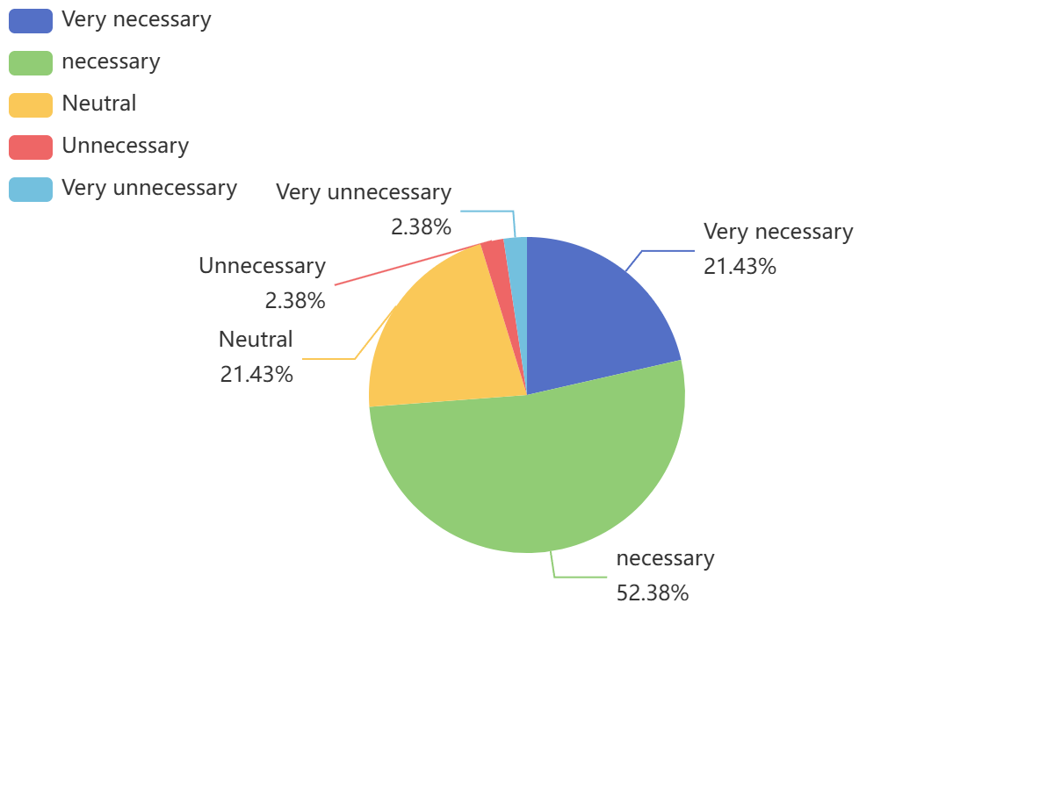

Figure : Perception of the gap between actual and ideal structures in software project management

Similarly, we have analysed the results of the questions by comparing them with the following figure, which shows that 28.57% of the people think that zoom-in and zoom-out of organisations is necessary and 38.1% think that it is necessary. More than half of the people think that zoom-in and zoom-out is necessary, which shows that most of the people are willing to try our modelling method.

Interview : "zoom-in and zoom-out are very useful for custom development companies, if a project fails, it can be used to analyse why their project failed and provide better decision making for post-project management, and the tool can also provide the A-side with suggestions for optimising the organisation in a more rational way. " --Chapter

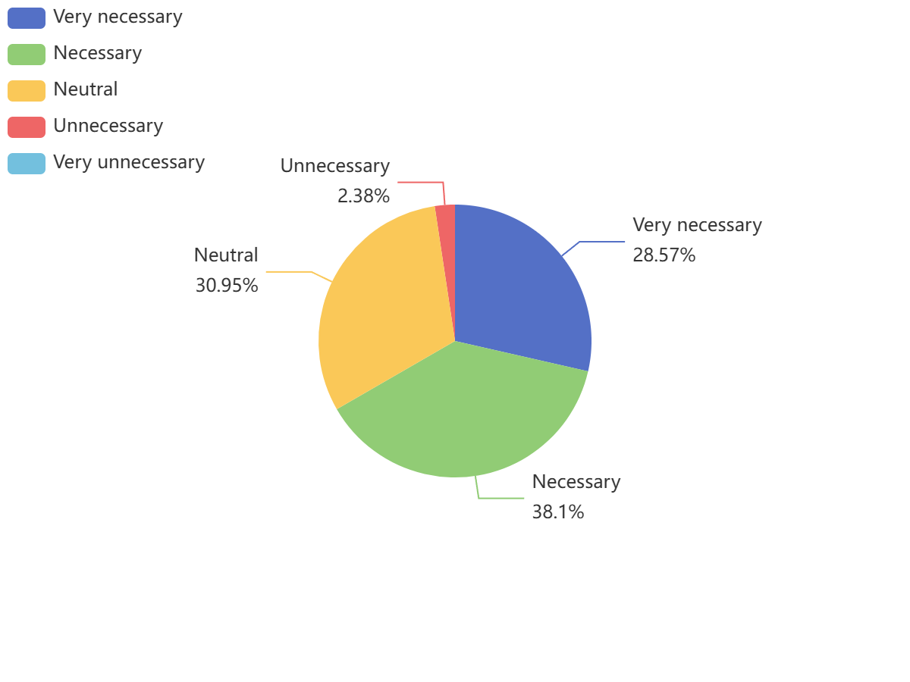

***Figure: survey respondents' perceptions of zoom-in and zoom-out in organisations***

In addition to this, we investigated whether Internet practitioners would be willing to use a tool that includes zoom-in, zoom-out and comparative modelling features when organisational changes are made to assist in organisational management of software projects. The results are as follows, 35.71% are willing to use it and 57.14% have a general attitude.

In our study, zoom-in is a detailed description of the hierarchical structure of an organisation, which can show more detailed information, such as departmental composition, communication channels and job responsibilities; zoom-out is an abstract description of the organisational structure, which can give an overall picture of the main information in the organisation, such as the general overview of each department. A normal organisation chart shows the approximate internal structure of an organisation, the zoom-out example shows the abstract internal structure of an organisation, and the zoom-in example shows the concrete internal structure of an organisation. By combining zoom-in and zoom-out, we are able to determine more accurately the relationship between hierarchies, which we have shown graphically in the questionnaire.

Interview: "I think both have their own advantages, in terms of zoom-out, Internet company leaders are basically from the bottom step by step up, as long as the leadership of my department and the upper level of communication can be solved problems, in this case zoom-out may be more optimal. But for example, government departments zoom-in may be superior." --Lee

In fact, however, we will pay more attention to the semantic aspects of the description, combined with the focus on context in the problem framework, zoom-in and zoom-out can more clearly describe the flow information between the domains, as shown in the figure below. Between abstraction and concreteness, we will focus on the relationship between domains in the same hierarchy, and then focus on the flow details, which is also our innovative part.

Finding:In a software project management, (1) it is necessary to compare the modelling of the ideal structure with the actual structure during organisational changes. (2) The use of a tool that includes zoom-in, zoom-out, and comparative modelling functionality during organisational changes is an innovative breakthrough in the software project process.

Interview : "zoom-in and zoom-out are very useful for custom development companies, if a project fails, it can be used to analyse why their project failed and provide better decision making for post-project management, and the tool can also provide the A-side with suggestions for optimising the organisation in a more rational way. " --Chapter

In addition, we had some additional findings from the fine-grained interviews.

Finding: All interview roles agreed that the level of clarity of project requirements should be emphasised, with requirements management, project managers and stakeholders generally considered to be important factors. Generic software focuses more on the implementation of business requirements, while customised software requires more technical difficulty and project managers. In China, most software projects do not involve multinational co-operation.

Interview content: "I think the role of demand management in the custom development of software inside the role is particularly large, custom development of software to achieve the final effect depends on the degree of clarity of the demand as well as demand controllable management, after the system is online, the demand for the department's demand will be more and more in the controllable range of the demand for this demand is clear, but also sorted out clearly, the boundaries of the demand should be managed and controlled! , which are reasonable requirements and which are unreasonable requirements, to distinguish." --Chapter

"I think the most important factor is the project manager, this is the key factor. Very often the cost, time, work attitude and to the professional planning, develop some management processes, as well as demand communication of the final realisation of the results need to be both sides of the project manager to influence both sides of the mutual cooperation." --Chapter